How to check whether the purchaser is buying genuine tickets or not?

1. Please check the Logo of the Punjab Government before buying the ticket.

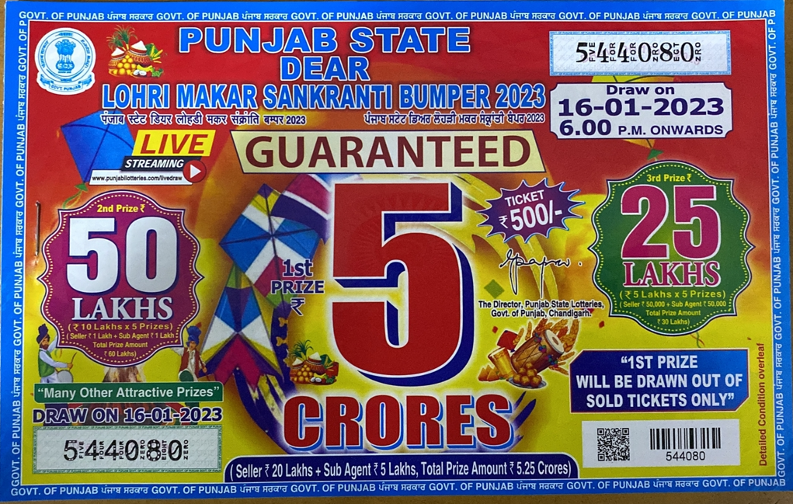

2. Please check the Government of Punjab is being written on all sides of tickets in English and Punjabi.

3. Please check the signature and official stamp of Director, Punjab State Lotteries to Department of Finance, Government of Punjab.

4. Please check the Bar code and Q R Code on each ticket.

5. Most important please check the ongoing bumper lottery draws on the official web site of the Government of Punjab i.e. www.punjabstatelotteries.gov.in

